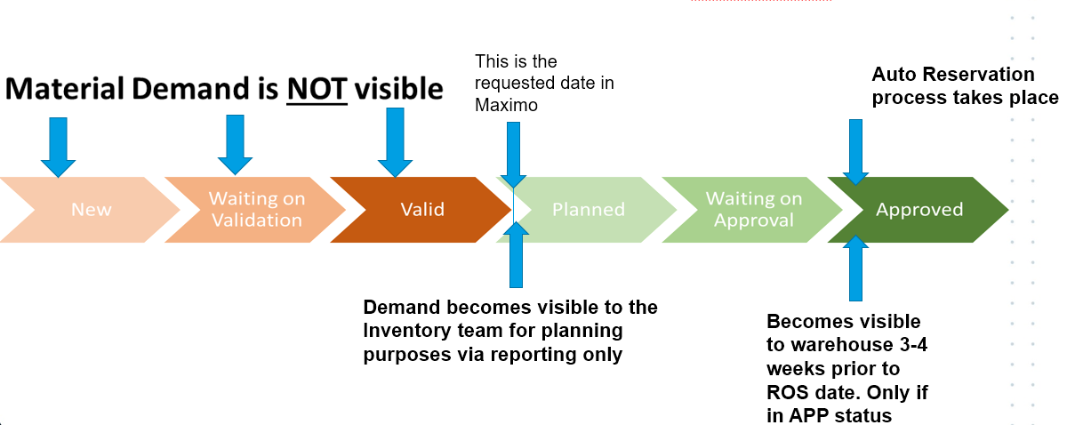
Figure 1: Visibility of Work Order Materials Requests

Auto Reservations
Transpower has turned on auto-reservation functionality in Maximo. This means that all material requests raised against a work order are automatically assigned one of the following statuses, based on the Required on Site (ROS) date, the availability of the item, and the inventory lead time for the material:
APSOFT: Maximo has automatically assigned a SOFT reservation to the item, meaning that the part is not reserved, but there is plenty of time to order and receive the material to execute the work plan (ROS date > current date + lead time + internal buffer). If that part is requested by another work order, with a ROS date < current date + lead time + internal buffer then Maximo will automatically allocate it to the earlier Work Order. Refer to Figure 2 for a visual representation of this.
APHARD: Maximo has automatically assigned a HARD reservation to the item, meaning that the item is specifically reserved for a Work Order and cannot be reallocate to another Work Order as there is not enough time (lead time) to order the material without impacting the work schedule. Refer to Figure 2 for a visual representation of this.
BACKORDER: Backorder status is applied when Maximo cannot allocate a hard reservation, as the item will not be available by the required date. Maximo will automatically update reservations to the backorder status when they cannot be fulfilled on time. Note: the status of BACKORDER will only be displayed in the reservations window.
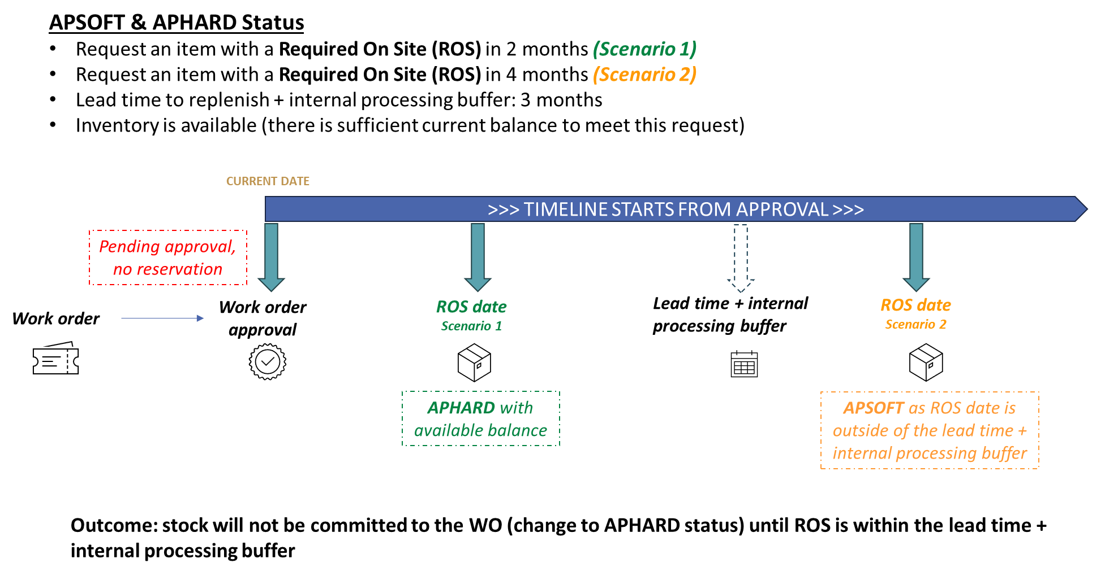
Figure 2: APSOFT / APHARD Statuses
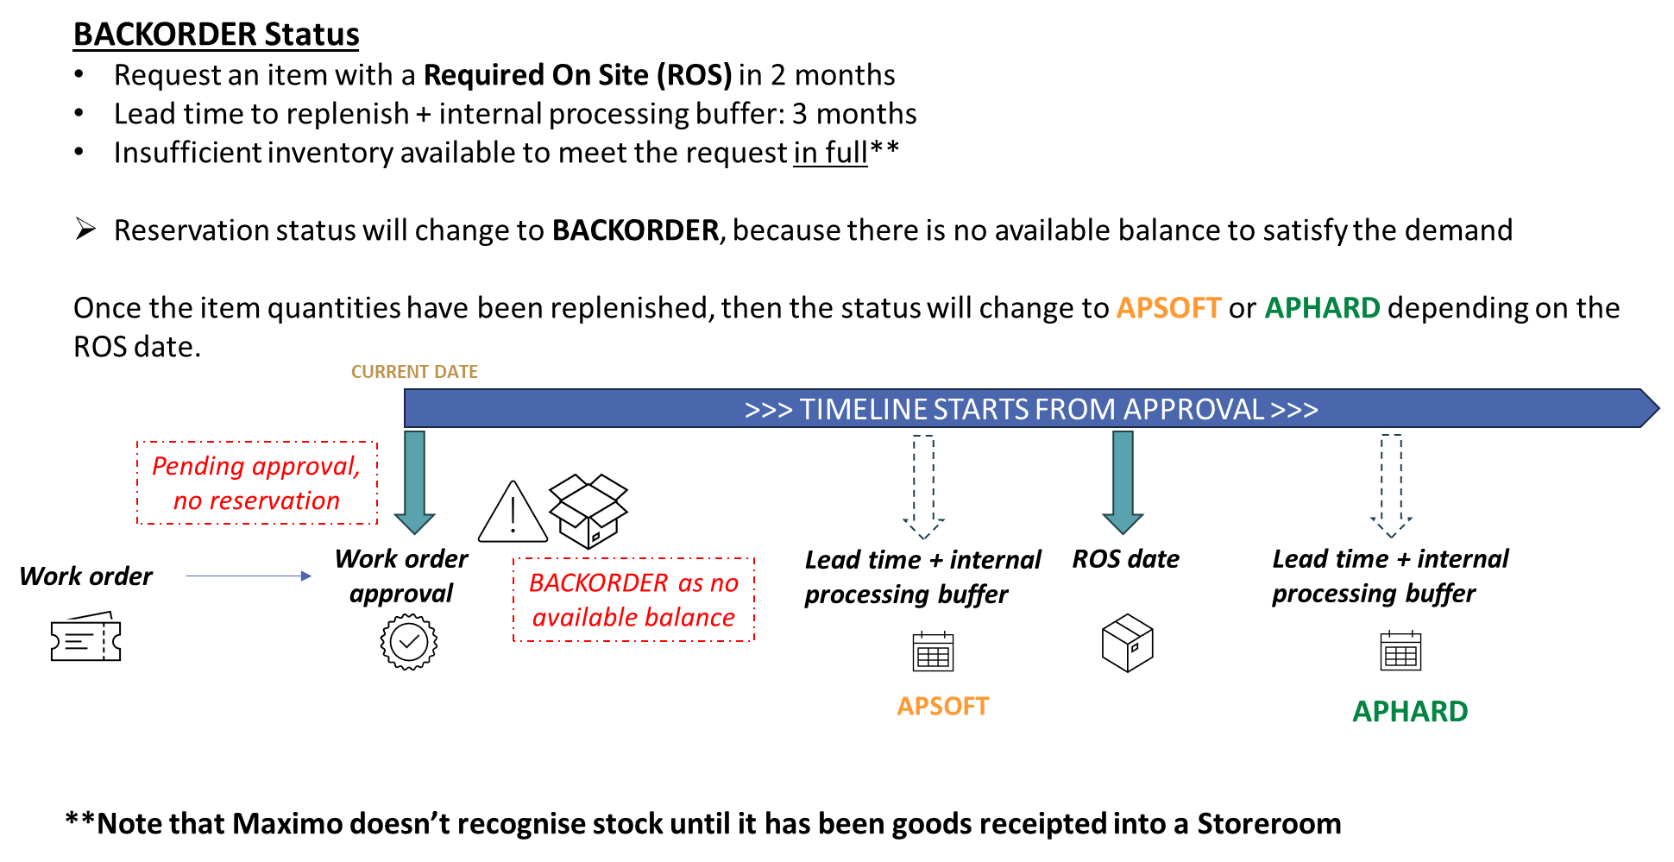
Figure 3: BACKORDER Status

Required on Site (ROS) Dates
Ensure that the Required on Site date matches the correct date the items are physically required on site. If a Work Order is moved from Valid to a status visible to the Inventory team, ensure that the ROS date is updated accordingly at this time.

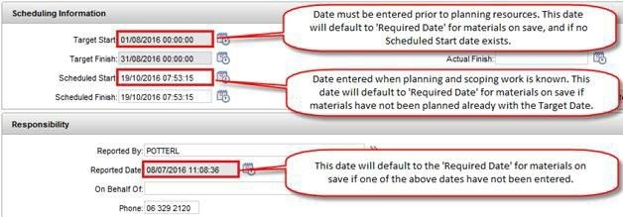
The information below outlines the correct process to enter dates into a work order.

Amendment to Material Reservations within 30 days of the Required on Site date
Amendments to material reservations on Work Orders in Approved status must be actioned by the relevant Warehouse Supervisor..
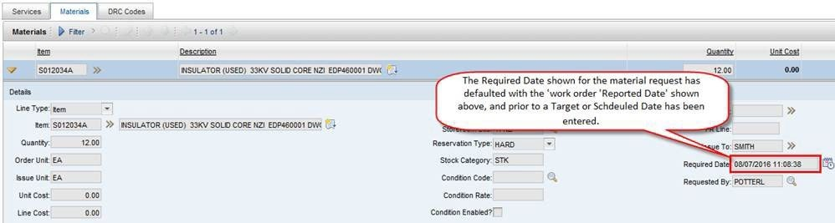
Please seek assistance from the relevant Warehouse Supervisor on how to manage a change to a materials request on a Work Order.

